Article
Public Sector Debt’s Effect on Economic Indicators and Real-Estate Investability
August Blomquist, Oliver Cheng, Alireza Darvishzadeh, Nolan French,
Jimmy Hernandez, Renata Krivenko, Connor Li, Luke Olmos
Saint Mary’s College of California: DATA 496
Abstract: This article analyzes public sector debt’s impact on economic indicators and real-estate investability across OECD countries in support of large U.S.-based private real estate firms. This paper uses statistical analysis, correlation techniques, and debt forecasting methods to determine the extent that public debt influences macroeconomic stability and investment potential. Economic indicators such as Inflation Rate, Unemployment Rate, and GDP growth were used to evaluate if countries could remain viable investment destinations even with high public debt levels. Social indicators like population growth rates, education rates, and corruption indices were used to evaluate the safety and long-term viability of property investments. The research aims to assist Horizon Development in identifying countries that are both fiscally sound and attractive for long-term real estate investment.

Keywords: Public Sector Debt, Real Estate, Investment, Economic Indicators

1. Introduction
Public Sector Debt refers to the amount of money a country’s government and public entities owes, both domestic and foreign. The public sector is made up of the federal government and organizations that operate under the federal government, along with state and state-operated organizations in countries like the US (1). These organizations normally operate for the good of the public, such as public education or public transit systems. Historically, public sector debt was mainly used to finance wars and guarantee border security through use of armies and mercenaries (2). In the 1800s governments started to issue bonds (a form of IOU that allows citizens to lend money to the government in return for interest) in order to finance public works such as infrastructure or education systems (3). In the 20th century, there was a large increase in the debt burdens on countries, likely due to the world wars and financial crises such as the Great Depression. These debt burdens were gradually resolved, but public sector debt rose throughout the world in order to fund social services such as pensions and health care.
Prominent economic experts have increasingly studied the relationship between public sector debt conditions, crime and education rates, and key economic indicators in OECD nations. Public sector debt conditions are best measured through metrics such as Average Debt, Debt-to-GDP, and Government Expenditure as a percentage of GDP. Key economic indicators are considered to be Real Inflation Rate, GDP Growth Rate, Unemployment Rate, Foreign Direct Investment (FDI), and Population Growth Rate. Many academic journals have examined fiscal sustainability’s impact on long-term financial health for these nations. Their results provide insight into public sector debt’s deleterious effect on investment attractiveness for major real-estate investment firms.
It is also important to use a holistic approach to determining investment attractiveness, considering elements like sovereign credit rating, monetary policy flexibility, and sector-specific risks. Qualitative factors such as geopolitical risks, regulatory stability, and compatibility with a firm’s core values must be considered for major investment decisions. Counterexamples such as the United States and Japan demonstrate that countries can remain desirable investment destinations due to monetary stability, a booming private sector, and strong fiscal policies even with high public debt levels. In this study, we will use statistical modeling, binary classification, real-world trends, and qualitative factors to cluster OECD nations based on their investment desirability to Horizon Development, a leading U.S. real-estate firm.

1.2. Literature Review
The 2024 work “Why the National Debt Matters for Housing” [1] by the Bipartisan Policy Center studies the effects of high public sector debt levels on housing. Their findings suggest that high debt levels weaken the government’s support of affordable housing initiatives. Consequently, reduced government spending increases mortgage rates and prevents low and middle-income households from affording proper housing. This debt also exacerbates existing supply-chain shortages and weakens investor sentiment in the bond market. This negative sentiment can lead to higher yields on government bonds, causing higher borrowing costs. Overall, not stabilizing debt levels can perpetuate the existing housing crisis by reducing government spending, weakening investor sentiment, and increasing mortgage rates.
The 2022 study “How Will Inflation Impact Commercial Real Estate” [2] by NAIOP, the Commercial Real Estate Development Association, analyzes inflation’s negative impact on the commercial real estate (CRE) sector. High public sector debt levels can lead to expansionary fiscal policies, which are linked to higher inflation rates. Inflationary pressures can drive up construction costs and rent prices, perpetuating the ongoing housing crisis. They also can cause higher borrowing costs and reduced CRE demand, creating investment uncertainty deterring long-term contracts. Countries with high public sector debt levels face limited fiscal flexibility to lessen inflation in the CRE sector, making them generally less desirable investment destinations. NAIOP encourages prudent fiscal and monetary policies to improve CRE sentiment and lessen rising inflation and public debt levels.
The 2021 study “The OECD Economic Outlook” [3] discusses the post-COVID challenges that advanced and emerging economies currently face. Public sector debt levels have reached unprecedented highs due to fiscal and monetary policies aimed at mitigating the negative financial effects of pandemic restrictions. OECD advises countries to initiate fiscal consolidation strategies following the end of the COVID-19 crisis to restore economic stability. They find that debt sustainability is also affected by investments in specific sectors such as technology, infrastructure, and innovation. They warn that high debt levels can negatively affect the private sector by crowding out investment, particularly in emerging and lower-income countries. They encourage countries to analyze public sector debt in conjecture with long-term growth strategies.
In the 2024 article “Modern Monetary Theory and its Implications for Public Debt” [4], Mitchell and Wray offer an alternative perspective to this paper’s findings and aim. MMT views sovereign countries with their own currency, such as those not in the Eurozone, can essentially print money to finance fiscal deficits to avoid the consequences of budget deficits. They view inflation, not the threat of sovereign debt, as the only limit to deficit spending. According to MMT, large-scale public debt may not be as harmful as traditional economic wisdom holds. Effective fiscal policies measures through taxation and government spending can mitigate inflation and prevent “overheating” in the economy. While critics argue that MMT causes hyperinflation and lessens investor sentiment, they argue it can enhance public investment without worsening debt sustainability. They stress that countries must have effective governance and proven fiscal and monetary policies to maintain economic stability and reasonable inflation levels to successfully apply MMT.
In the 2019 work “Public Debt and Low Interest Rates”, [5] Blanchart argues that a country can mitigate high debt levels by having its economic growth rate exceed its borrowing cost. He emphasizes that externalities, shifts in investor sentiment, and monetary policy changes can still impact a country’s financial health. He views persistently low interest rates as potentially mitigating rising concerns about debt sustainability.
In the 2012 work “The impact of high government debt on economic growth” [6], Checherita-Westphal and Rother consider debt’s impact on economic sustainability in the European Union. According to research, high debt levels kickstart negative growth effects when Debt-to-GDP levels reach approximately seventy-five percent. They found that failures in fiscal policy transmission, such as public investment, and total factor productivity, cause the correlation between high debt rates and low long-term growth rates. They also emphasized that governmental response to rising debt levels, such as structural reforms, productivity growth, and lower debt growth rates, can help mitigate economic slowdowns caused by excessive public debt.
Comparatively, in the 2015 work “Public debt, economic growth, and nonlinear effects: Myth or Reality?,” [7] Egert emphasizes that countries whose debt-to-GDP ratio exceeds 90% can mitigate slowed growth rates through effective governance and transparent fiscal policies. Compared to Rogoff and Rother, he is more opposed to using a universal debt threshold to measure economic stagnation risk due to non-linear effects like governance and economic stability.
The 2016 study “Great Mortgaging: Housing Finance, Crises, and Business Cycles” [8] by Jordà, Schularick, and Taylor finds that economic downturns are usually associated with dramatically increased levels of public sector debt. Their research encourages emerging economies to develop better debt sustainability frameworks. These findings explain how public debt affects financial differentiation among nations and their economic scores, such as credit ratings, GDP growth, inflation control, and fiscal balance. Countries with sustainable debt levels will usually score higher in these indicators due to their better economic performance. Meanwhile, high-debt nations have higher borrowing costs and greater economic instability that negatively affect their economic performance. Overall, this work reveals that fiscal stability and debt sustainability usually improve a country’s economic score through an enhanced credit rating.
In the 2010 work “Growth in a Time of Debt” [9], Reinhart and Rogoff argue that countries will suffer low growth rates if their public sector debt is at least ninety percent of their GDP. High-debt countries have a one percent lower median GDP growth rate and an even lower mean growth rate than other lower-debt countries. Additionally, their research suggests that a significant correlation exists between high debt levels and rising inflation levels in emerging markets. They found that countries may damage consumer confidence and risk unforeseen financial catastrophes if they excessively borrow money to repay their debt. However, this study remains controversial and fiercely debated due to alleged computational errors and unfounded findings on arbitrary debt thresholds. Critics argue that this study takes an excessively reductionist approach by failing to consider qualitative factors like monetary policy, external economic conditions, and effective governance. For example, countries can use monetary policy tools like interest rates and quantitative easing to prevent high-debt levels from causing lower growth rates.
Finally, Freddie Mac’s 2021 report, “As the Population Keeps Growing, So Do Housing Needs” [10], examines the relationship between population growth and housing demand. Their forecasts suggest that due to population growth and demographic shifts, the United States will need approximately four million new homes in the next ten years. They view high public sector debt levels as a central threat to weakening the housing supply. Their findings suggest that these high debt levels prevent the government from properly financing infrastructure and housing programs. They also view high public sector debt as driving up inflation rates, making it financially impossible for many citizens to afford housing. They advocate for continued governmental support of low-income housing while maintaining reasonable debt levels.

1.3. Similar Work and Context
Institutions such as the IMF and World Bank have recently begun studying public sector debt’s effect on key economic indicators. Their findings call for more careful fiscal policies in higher-risk, less stable OECD countries like Chile and Greece. The European Central Bank has found that central banks must be able to manage inflation and interest rates effectively even with high debt levels.
Comparatively, this study uses findings gathered from the literature review with relevant economic modeling and scoring to assess the impact of debt on investment attractiveness for OECD nations. By using binary classification and several machine learning algorithms, this research hopes to show a more specific impact of high debt levels on GDP growth, unemployment, and inflation.
This paper’s analysis builds upon previous research findings by using six datasets from thirty-seven OECD countries from 2010 to 2023. Unlike traditional academic journals, this paper hopes to compare multiple economic zones and OECD economies to identify multi-year trends.
This paper is being written in the middle of an international trade war, which involves many OECD countries and which public debt is a prime factor in.

1.4. Aim of Paper
The main objective of this project is to understand the effects of public sector debt on key economic indicators and real estate profitability. This paper seeks to answer the research question of, “How does Economic Status and Public Sector Debt Affect Real Estate Investability?”
This paper aims to assess public debt conditions, analyze real estate, socioeconomic, and political trends, and identify causes of public debt levels for thirty seven OECD nations selected by Horizon Development. The paper’s primary objective is to assess desirable and undesirable target markets for Horizon Development to expand into based on real-world data, statistical modeling, and trends in the political and real-estate dimensions. This study will provide Horizon Development with a better understanding of macroeconomic stability in each country, guiding their investment decision-making. Countries with high debt levels may still be a recommended target market based on their fiscal policies, political and economic stability, and debt sustainability. Conversely, countries with low debt levels still may not be recommended if their values are inconsistent with Horizon’s or concerning trends from 2010 to 2023 are identified by the model. Overall, this paper’s primary aim is to use trends, modeling, and public sector debt levels to cluster the OECD countries based on their investment desirability to Horizon.
1.5. Structure of Paper
This paper is organized into eight sections. The title and abstract will identify this study’s main objective, findings, and conclusions. The Introduction will include a definition of our measures, a Literature Review, a Similar Work and Context section, an Aim of Presentation section, and a Structure of Paper section. The Introduction will place this study in the context of other academic works while establishing Horizon Development’s vision with this project. The Methodology section will describe the study’s work performance. The Results section will include the study’s data, relevant data visualizations, and brief comments for Horizon decision-makers. The Discussion section will include analysis of results, including unexpected findings and outliers. It will compare the findings with the paper’s original aim and address any lingering research questions. The Conclusions section will summarize our findings and objectives. The References will feature our sources analyzed in the Literature Review and used to enhance our understanding of the topic at hand.

2. Methodology
A group of eight students in the Data Science Capstone at Saint Mary’s College of California was tasked with evaluating OECD countries for their real estate sustainability to provide strategic recommendations for Horizon Development. They were instructed to prioritize factors relating to real estate and the broader economy–specifically interest rates, public sector debt, education levels, crime rates, unemployment, inflation, and GDP–while excluding countries currently experiencing economic distress or projected to face economic distress by 2030.

2.1. Data Collection and Preprocessing
A total of nineteen datasets were used for modeling and statistical analysis. Five of these datasets were obtained from the OECD website, via the course professor. These datasets were Inflation Percentage, National GDP in USD, Unemployment Rate, Standardized Population Growth Rate, Public Sector Debt (% of GDP), and Annual Inflation Percentage. These datasets contained relevant data for thirty-seven OECD nations, excluding Israel, spanning from 2010 to 2023. Data prior to 2010 included in the original CSV files was filtered out by students. Each student utilized Python and relevant libraries, including pandas, to clean, filter, and analyze datasets drawn. These filtered data sets were then reuploaded into a shared class Google Drive folder. Relevant datasets had Country Codes and missing countries added. GDP (USD) was converted to year-over-year growth. Crime Index (2025) and Education Rate (2024) were obtained from World Population Review. Annual Inflation Rate (2010-2023) was found on the World Bank and the non-OECD countries were filtered out. Consumer Price Index (CPI), Tax Revenue (% of GDP), Urban Population Growth Rate, GDP per Capita, Foreign Direct Investment (FDI), Export of Goods & Services, Imports of Good & Services, Current Account Balance (USD), and Labor Force Participation Rate were also used, obtained via the World Bank DataBank. Two features were sourced externally, with Corruption Perceptions Index from Transparency International and Average Wages from OECD. All datasets were imported into Python using Google Colab.
All variables were converted into year-over-year (YoY) using Google Colab. The target variable was defined as Public Sector Debt (% of GDP). The feature variables were defined as economic indicators that were statistically significant at the 0.05 significance level. The regions were European countries, non-European countries, and all 37 OECD countries. 26 countries are classified as European countries, with the remaining 11 classified as non-European.

2.2 Clustering and PCA
Following preprocessing, all countries were grouped using PCA analysis and K-means clustering. Data was standardized using StandardScaler. PCA analysis was performed in order to recognize patterns and similarities in the variables. The dimensionality was reduced into 2 primary components. The countries were clustered into two groups defined as Tier 1 and Tier 2. Tier 1 countries were deemed “debt-resilient” while Tier 2 countries were considered non-viable countries to invest in. Therefore the Tier 2 countries were dropped from further analysis in order to reduce outliers and increase accuracy.

2.3. Correlation and Weights
For each group, Pearson Correlation Coefficients were calculated between Public Debt each factor using scipy.stats.pearsonr. Correlations were filtered by p < 0.01 significance level to ensure statistical significance. Statsmodel.api was used for linear regression to have a second metric for correlation significance.
The purpose of using correlation was to derive weights for public sector debts. Significant correlations, where p <0.02, were converted into weights for the normal scenario. Weights were calculated by taking the absolute value of each correlation to ensure positive weights. The correlation coefficients of all factors were added up. Each correlation was divided by the total for normalization purposes, ensuring the weights sum to one.
These weights play a crucial role in prediction. They determine the influence of each factor on public Debt growth in the different scenarios. For example, a high inflation weight (0.197 European) means rising inflation significantly increases debt growth.
Seven factors stood out as significant with p-values less than 0.01 and VIF under 10. These factors include labor force, inflation, unemployment, population, wage, GDP per capita, and corruption. These factors were used in a predictive model to forecast debt levels to 2030 achieving an adjusted R-squared of 0.71 along with a root mean square error of .34 meaning that the predicted variables could be off by + .34 or - .34, which is quite accurate in this context.

2.4 Predictions
Using the ARIMAX forecasting model we created time series forecasts for years 2024-2030. Variables used were the final_features that were deemed significant during the earlier PCA analysis and linear regression.

2.5 Debt Risk Score
In order to rank the OECD countries, analysis utilized the debt risk score, which was found using the following formula:
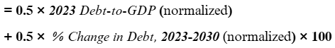
Countries with a score of 0-30 are deemed low risk, and therefore good investment opportunities. Countries with scores 31-60 are at moderate risk. 61-100 are high risk countries, which are not great places for investment due to their unpredictable nature and economic factors.
In order to determine where to invest, OECD regions were ranked by the mean of the countries within each region.

3. Results
3.1 Linear Regression and Feature Significance
From the PCA and feature analysis, 7 of the 19 features were deemed significant, having a p < .01 and VIF < 10. These variables included labor force, inflation rate, unemployment rate, population growth, average wage, GDP per capita, and corruption perception index. Labor force was the most highly correlated positive feature, while corruption perception was the most highly correlated negative feature.
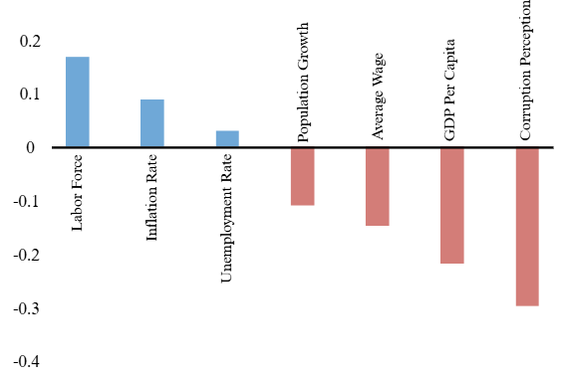

3.2 ARIMAX Modeling
The results of the ARIMAX model indicate that average public debt increased from 2010 - 2013 and spiked in 2019 - 2020. However, forecasting indicates that public debt will be stable 2024 - 2030 at ~61% of GDP.
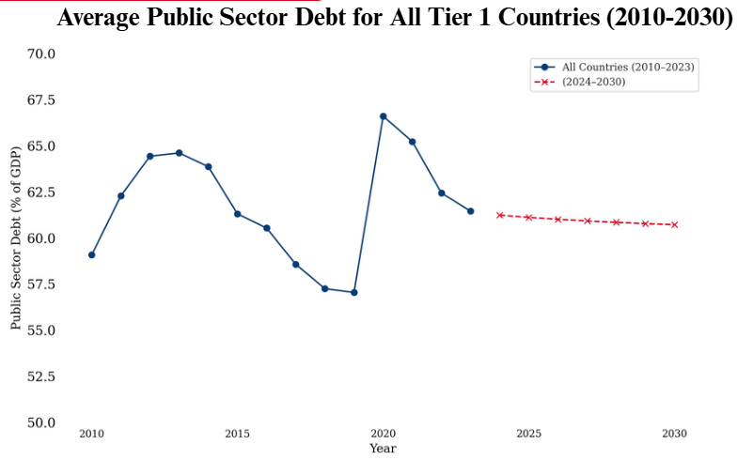
3.3 Debt Risk Scoring and Regional Investment Risk

Of the Tier 1 OECD countries, the mean Debt Risk score was 46.5 and the median was 47.8. The US score (used as a baseline to compare) was 70.5. Japan was an outlier with a score of 95.8.

When the regions of OECD countries were separated and ranked by their mean debt risk score, Northern Europe came out as the most secure region to invest in, followed by North America. The “Other” region is made up of the remaining countries, including Australia, Japan, Italy, and New Zealand. It came up as the region with the highest Mean Debt Score.

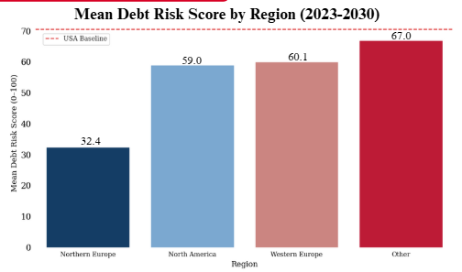

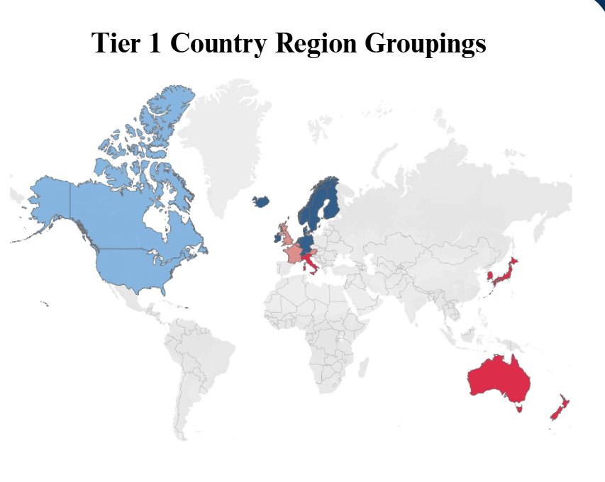

3.4 Recommendations

The top 5 countries based on debt risk score (lower is better) include the four Scandinavian countries along with Ireland. These are the countries that Horizon Development should invest in.

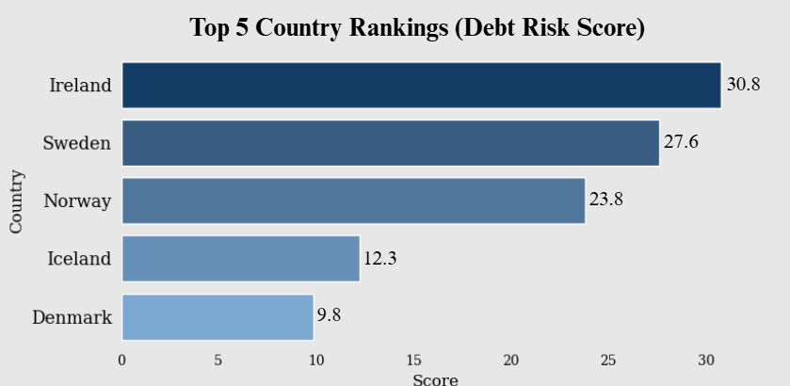

When compared to the USA, the Northern European countries have much lower levels of public debt, and have a trend of decreasing their debts since 2012. While public debt spiked in 2020 for both groups, the Northern European countries saw a much smaller spike, and public debt has recovered to pre-Covid levels while the US public debt continues to increase. The forecast shows a further increase in US public debt while there is a decrease in Northern European public debt in 2025 - 2030.

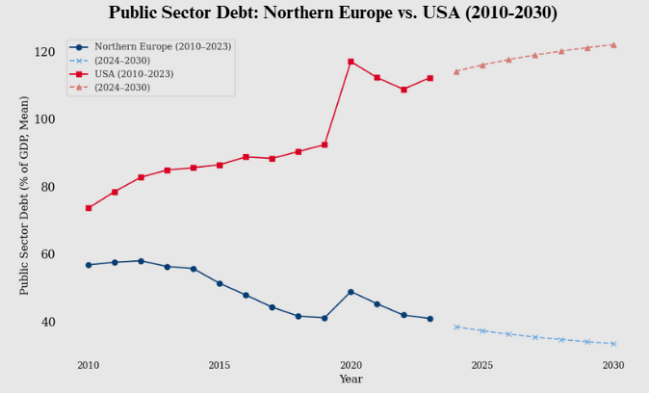
4. Discussions
4.1 Significant Features
The seven significant features fall into three positively correlated features and four negatively correlated features.The positive features (labor force, inflation rate, unemployment rate) increase when public debt increases. For example, increased public borrowing can spur economic growth, creating more jobs and raising the labor force. Inflation can also increase as public debt increases, due to governments printing more money in order to pay off debt. And while it is not as positively correlated, unemployment can increase when public debt hurts economic growth, due to rising interest rates that cool the economy. However, this is further down the public debt pipeline. The negative features include population growth, average wage, GDP per capita, and corruption levels. Larger populations can increase tax revenue, leading to a greater ability to pay off debts. They also stimulate the economy through increased consumer spending, facilitating economic growth without borrowing. As average wage and GDP per capita increases, public debt decreases, meaning these are signs of a thriving economy that doesn’t need increased debt to grow. While it seems like increased corruption levels would increase public debt, it might cause a decrease in available tax revenue due to tax evasion or bribery. This might initially cause a decrease in borrowing, however there likely will be strong economic penalties further down the road.
4.2 Recommendations
Due to their countries’ stable economies and lack of reliance on public debt, the Northern European countries - consisting of the Nordic countries along with Ireland. These countries are known as some of the most wealthy western countries, along with having low levels of corruption and crime. The Nordic countries especially have high average wages, which was also determined during feature significance to correspond to decreased levels of public debt.
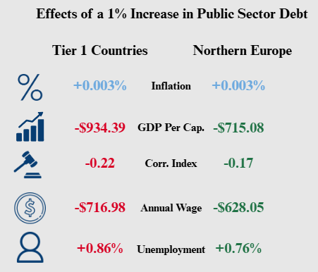
When analyzing the effect of a 1% increase in public sector debt, Northern Europe (NE) fares much better than the average of the Tier 1 countries. There is a $200 difference between the decreases in GDP per capita, which might indicate that increased public debt has more adverse effects on Tier 1 countries. Changes in annual wage and unemployment are also less than the average, which may indicate greater labor protections and social safety nets, which is likely since the Nordic countries are considered to be as they are “welfare states”. This indicates that NE countries have more robust economies and feel the effects of public debt less. Inflationary pressures seem to be minimal and the same whether in the Tier 1 or NE countries, as both increase by .003% every 1% increase of public sector debt. Additionally, the debt to GDP ratio of the NE countries is set to fall by 5.03% on average from 2024 -2030, meaning these countries will become even more stable in the next half-decade.
4.3 Limitations
One significant limitation is missing or null data. For example, it was difficult to obtain accurate and up-to-date information for the government's expenditure on education. The World Bank abruptly halted their collection of this data in 2022 while the rest of our data was collected through 2023. Similarly, the World Bank did not even collect data for one OECD country, Colombia.
Another issue is multicollinearity, as many of our feature variables such as population growth rate and urban population growth rate may be highly correlated with one another. However, this was mainly solved by decreasing the number of features from nineteen to seven through PCA.
The applicability to real-world investment decision-making is limited by qualitative factors not considered by binary classification, clustering, time-series analysis, and machine learning models used by the paper. The paper only briefly addresses regulatory stability, property rights enforcement, and upcoming geopolitical threats. Investment firms would be remiss not to consider these factors, which were difficult to classify and categorize with the datasets used. Hence, the practical value to real estate investors moving forward may be limited as news events and externalities present shockwaves to existing public sector debt levels and fiscal policies.
The paper’s methodology assumes that high debt levels are a universal warning sign to all potential real-estate investors. However, counterexamples like Japan and the United States demonstrate why this may not always be the case. Additionally, some investors may prefer riskier investments that offer potentially higher rates of return. Counter-strategies like investing in distressed assets or higher-yield, higher risk markets may be deemed more suitable for investors depending on their risk tolerance and investment portfolio. Future research should better focus on preferences by percentage for major real estate investors.
5. Conclusion
This study illustrates that public sector debt has a profound effect on a nation’s economy, which can translate to the value of their real-estate market. Through analysis of 37 OECD countries from the years of 2010 - 2023 using PCA, clustering, linear regression, and time series modeling, we were able to determine seven features that were significantly correlated to increased public sector debt. These included labor force, inflation rate, unemployment, population growth, average wage, GDP per capita, and corruption perception.
Our analysis revealed that while increased public debt affects the economies of every OECD country, there are significant differences in the amount that it affects each country. Using the debt risk score, countries were ranked on how much debt they have to their GDP over a period of time. This helped to quantify the risk of them being unable to pay back their dues, along with illustrating which regions had low debt levels.
When choosing which countries Horizon Development should invest in, the researchers encourage them to consider the Nordic countries, along with Ireland. They have low debt to GDP ratios, along with high wealth levels and low corruption levels. When compared to the USA as a baseline, the Northern European countries had much lower levels of public sector debt, along with a trend of decreasing that debt over the last decade, as well as in the forecasted future. And when compared to the average of the Tier 1 countries, they were much more resilient in public debt’s effects on GDP per capita, unemployment, and annual wage. This indicates they have highly effective fiscal policies and are very stable - both good things when looking at the investability of a country.
Ultimately, countries should be considered holistically and should take into account their governing system, history, and resources. However, this research offers an analytical perspective on the effects of public debt that may be useful in conjunction with other sources of information.

Acknowledgements: We would like to thank Saint Mary’s College of California, SEBA, and the Business Analytics Department for their support over the last four years. We would like to thank Professor Safwat Hamad for his valuable feedback over the last two months during this project.
Conflicts of Interest: The authors declare no conflict of interest.
References
- Trevino, Aranza. “What Is the Public Sector?” Edited by Anne Cutler and Darren Guccione, Keeper Security Blog - Cybersecurity News & Product Updates, 24 Jan. 2024, www.keepersecurity.com/blog/2022/09/26/what-is-the-public-sector/#:~:text=When%20it%20comes%20to%20ownership,by%20private%20individuals%20and%20companies.
- Stasavage, D (2011), States of Credit: Size, Power, and the Development of European Polities, Princeton University Press.
- Mitchener, Kris, et al. “Public Debt through the Ages .” Public Debt through the Ages | CEPR, 1 Apr. 2019, cepr.org/voxeu/columns/public-debt-through-ages.
- Bipartisan Policy Center. (2024). Why the national debt matters for housing. Retrieved from https://www.freddiemac.com/research/insight/20210128-population-growing
- NAIOP, the Commercial Real Estate Development Association. (2022). How will inflation impact commercial real estate? Retrieved from https://blog.naiop.org/2022/01/how-will-inflation-impact-commercial-real-estate/
- OECD. (2021). Economic Outlook: A comprehensive overview. OECD Publishing.
- Mitchell, W., & Wray, L. R. (2024). Modern monetary theory and its implications for public debt. Retrieved from https://www.themortgagenote.org/how-do-unemployment-rates-affect-the-housing-market/
- Blanchard, O. (2019). Public debt and low interest rates. American Economic Review, 109, 1197–1229.
- Checherita-Westphal, C., & Rother, P. (2012). The impact of high government debt on economic growth. European Economic Review, 56, 1392–1405.
- Égert, B. (2015). Public debt, economic growth, and nonlinear effects: Myth or reality? Journal of Macroeconomics, 43, 226–238.
- Jordà, Ò., Schularick, M., & Taylor, A. M. (2016). The great mortgaging: Housing finance, crises, and business cycles. Economic Policy, 31, 107–152.
- Reinhart, C. M., & Rogoff, K. S. (2010). Growth in a time of debt. American Economic Review, 100, 573–578.
- Freddie Mac. (2021). As the population keeps growing, so do housing needs. Retrieved from https://www.freddiemac.com/research/insight/20210128-population-growing
- Britannica. (n.d.). Eurozone debt crisis. Retrieved from https://www.britannica.com
- Macrotrends. (2023). European Union youth unemployment rate. Retrieved from https://www.macrotrends.net
- Statista. (2024). Youth unemployment rate in EU countries. Retrieved from https://www.statista.com
- OECD. (2020). OECD Economic Surveys: Korea. OECD Publishing. Retrieved from https://www.oecd.org
- World Bank. (2020). Global economic prospects: COVID-19 and the global economy. World Bank. Retrieved from https://www.worldbank.org
- Federal Reserve. (2019). Monetary policy report. Board of Governors of the Federal Reserve System. Retrieved from https://www.federalreserve.gov
- Reuters. (2025). Profits for Colombia’s Ecopetrol slide 22% in 2024. Retrieved from https://www.reuters.com
- Statista. (2023). Economy of Costa Rica – Statistics & Facts. Retrieved from https://www.statista.com
- European Commission. (2020). Latvia: Economic recovery and emigration trends. Retrieved from https://www.ec.europa.eu
- World Bank. (2024). Turkey economic update: Political and market stability. Retrieved from https://www.worldbank.org
- World Bank. (2020). Japan: Employment and Labor Market Overview. Retrieved from World Bank
- OECD. (2020). Economic Survey of Norway. OECD Publishing. Retrieved from OECD
- German Federal Statistical Office. (2020). German Economic Outlook. Retrieved from Destatis
- World Bank. (2016). The Impact of the Oil Price Decline on Developing Countries. World Bank.
- World Bank. (2020). Global Economic Prospects: COVID-19 and the Global Economy. World Bank.
- Daly, Linda, and Jon Ihle. “Will a Booming Economy Sway the Irish General Election?” The Times & The Sunday Times, The Sunday Times, 26 Oct. 2024, www.thetimes.com/world/ireland-world/article/will-a-booming-economy-sway-the-irish-general-election-h9dbbvjv
- Mexico Central Bank Has Growing Inflation Challenge: Extortion | Reuters, www.reuters.com/markets/mexico-central-bank-has-growing-inflation-challenge-extortion-2024-08-27/
- Migration Flows: Eastern, Central and Western Mediterranean Routes - Consilium, www.consilium.europa.eu/en/infographics/migration-flows-to-europe/
- Walter, Rebecca J, et al. “Association between Property Investments and Crime on Commercial and Residential Streets: Implications for Maximizing Public Safety Benefits.” SSM - Population Health, U.S. National Library of Medicine, 30 Nov. 2023, pmc.ncbi.nlm.nih.gov/articles/PMC10757037/
- “Why Is Inflation so Low in Japan?” World Economic Forum, www.weforum.org/stories/2022/10/why-japan-low-inflation/

Previous Versions of this Article
French, Nolan, et al. Real Estate Investment Attractiveness for OECD Countries, 27 Feb. 2025. https://docs.google.com/document/d/1ZAnvB36PPswE60VuJuY019TqEmFDWVXh/edit
Blomquist, August, et al. Real Estate Investment Through Economic Analysis, 27 Feb. 2025. https://docs.google.com/document/d/1XdiaMAmoRjECpTuqYr5HXh6_ZOlMkA-gM7qUS3JcNak/edit?tab=t.0

